Login Function in Python using Mongodb

Software Security – Assignment

(COHDSE182F-025 – G. S. P. Perera)

Details of Database:

Database Name : login

Collection Name : users

Document Name : doc

My steps for create login form with python & mongodb

1. First I installed the mongodb for create database & settled path for mongodb for command prompt.

2. After the did that, I type in command prompt”mongod” to confirm have or not mongodb.

3. After I wanted to install pymongo driver to easily work to python code with mongodb.(For it to type” pip install pymongo” in cmd)

4.After I created the python code and I save it as“doc.py”(my create python code below ).

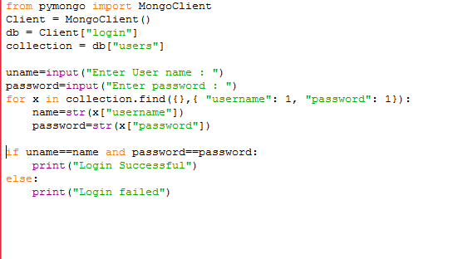

5.After I type “python” in command prompt and created database typing as below in command prompt.

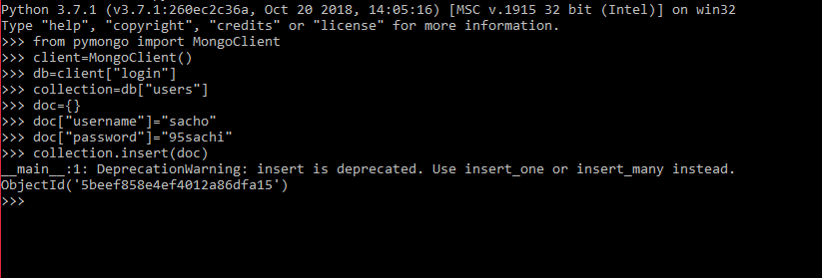

6.My created databaese below

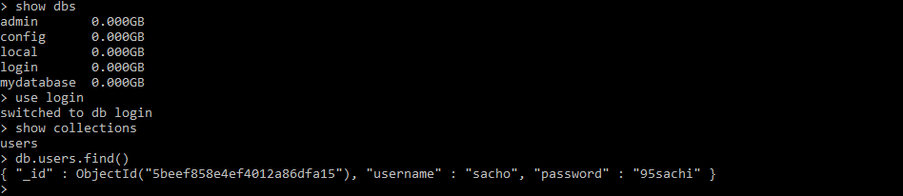

7.Out put of my create login form

